Install mlpi on Linux for development:

* Copy libmlpi.so.1 to /usr/local/lib
* Copy dllmlpinet.dll to /usr/local/lib
* In /usr(local/lib create symbolic link libmlpi.so to libmlpi.so.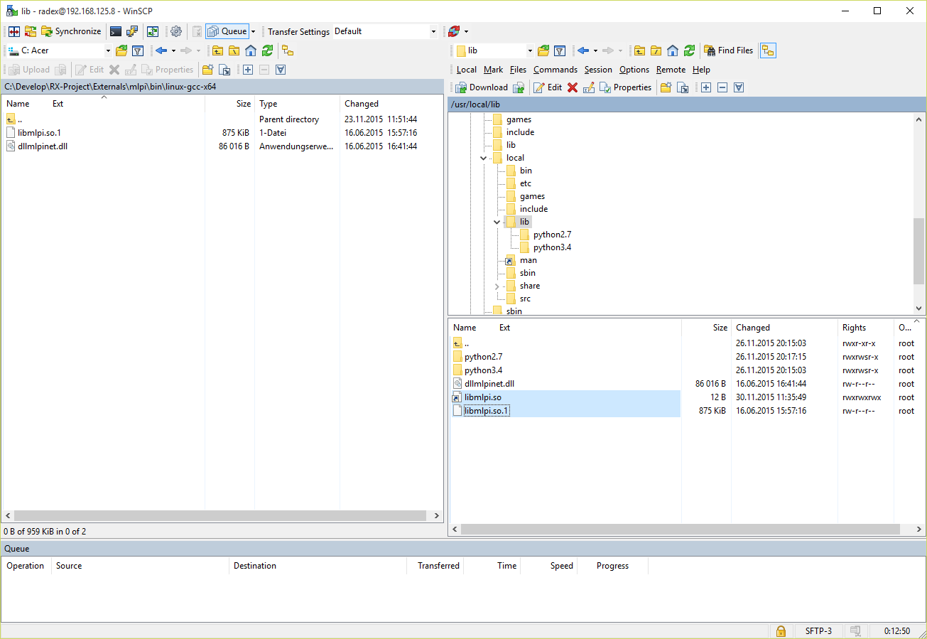1